Name: Brooks Hanson

1. True/False (1 point each)
   1. Classes have attributes and methods ____T_____
   2. The first parameter of a method is a reference to the instance calling it and is usually called self ____T_____
   3. The quick sort algorithm is always the fastest sort algorithm to use ___F____
   4. A queue abstract data type usually has methods for push, pop, and peek ____F____
   5. You can find the end of a linked list in constant time ___T____
2. Given the following initial list of random integers: [5, 23, 17, 89, 2, 1, 12]
   1. What is the resulting list after one pass in a selection sort? (5 points)
   2. What is the resulting list after one pass in a bubble sort? (5 points)  
      [5, 23, 17, 89, 2, 1, 12]
   3. What would be the most efficient pivot point to use in a quick sort? (5 points)  
      12
3. What is the worst-case time complexity, in Big O notation, of a sequential search on a random list? (10 points)  
     
   O(n)
4. Given a binary search tree with 22,000 nodes and a depth of 10 what is the maximum number of nodes you would have to examine to search for a value? (10 points)

A depth of 10 means that the roots go ten edges down. This means that to get to the bottom of the tree, you would examine the root node plus 10 children nodes, worst case, which equals 11 nodes at maximum.

1. There are two primary components of a tree abstract data type: nodes and ____________   
   (5 points)  
     
   Edges
2. Which abstract data type did we cover that supports both FIFO and LIFO? (5 points)  
   Deque
3. What is the time complexity of a search of a hash table with no collisions present? (5 points)  
   O(n)
4. Given the following class and code, answer the subsequent questions (1 point each)

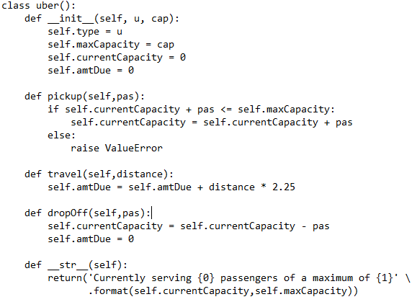

U = uber(‘X’,4)  
U.pickup(1)

U.travel(10)

U.pickup(1)

U.travel(5)  
What are the values of:

U.type _____________________’X’_______________________

U.maxCapacity ______________________4_______________________

U.currentCapacity ______________________2_______________________

U.amtDue ______________________22.25_______________________

str(U) ‘Currently serving 2 passengers of a maximum of 4’